Sept 7, 2025
Welcome! We are so glad you joined us today.
We pray that you will be blessed!

Speaker: Pastor Dennis Wenceslao
Message: Experience HIS Power
Text: Joshua Joshua 6:1-21

Joshua 6:10-16

10 When the governor motioned for him to speak, Paul replied: “I know that for a number of years you have been a judge over this nation; so I gladly make my defense. 11 You can easily verify that no more than twelve days ago I went up to Jerusalem to worship. 12 My accusers did not find me arguing with anyone at the temple, or stirring up a crowd in the synagogues or anywhere else in the city. 13 And they cannot prove to you the charges they are now making against me. 14 However, I admit that I worship the God of our ancestors as a follower of the Way, which they call a sect. I believe everything that is in accordance with the Law and that is written in the Prophets, 15 and I have the same hope in God as these men themselves have, that there will be a resurrection of both the righteous and the wicked. 16 So I strive always to keep my conscience clear before God and man.

Last Sunday's Worship In-Person Attendance and Offering
 | Glendale | SGV |  |  | Diamond Bar |  | ACC |  | Arcadia
 | Glendale | SGV | HOA |  |  |  |  |  | Arcadia |  | GCDC
Mandarin | 102 | 220 | 66 |  | 96 |  | -- |  | 33 |  | 18
Cantonese | 22 | 136 | -- |  | 84 |  | -- |  | 104 |  | --
English | 147 | 65 (Retreat) | -- |  | -- |  | 84 |  | 59 |  | --
Youth | w/English | 49 | 25 |  | 15 |  | -- |  | 19 |  | --
Total: 1,344
 |  | Glendale |  | SGV |  | Diamond Bar |  | ACC |  | Arcadia
General Fund |  | 13,313.36 |  | 17,702.00 |  | 11,646.91 |  | 5,926.55 |  | 6,590.00
FECA Mission Fund |  | 857.00 |  | 70.00 |  | -- |  | -- |  | 50.00
Others |  | 715.00 |  | 2,192.00 |  | 6,120.30 |  | 20.09 |  | 345.00
07/25 Sur./Def. |  | 15,509 |  | (15,462) |  | (22,577) |  | 4,305 |  | (7,113)
01-07/25 Sur./Def. |  | 106,734 |  | (102,161) |  | (122,587) |  | 39,438 |  | (8,907)

Announcements:
1. We will be conducting a Membership class on Sept 14, at the Chapel right after the service. Please approach P. Dennis to register.
2. Young Adults Men – let us have fellowship on Sept 28, at the Chapel right after the service. Lunch will be provided.

First Evangelical Church Association
- FECA 2025 Praise & Worship Joint Missions Conference - register at www.feca.org
October 3 & 4 -- Hilton San Gabriel Valley, October 5 — Member Churches
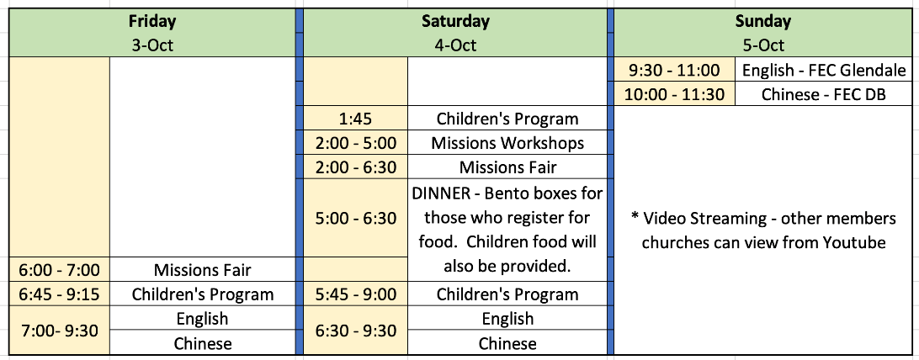
Theme: From the Altar to the Nations - Enter into Worship. Go Out in Love
- Seeking Candidates for the Position of Missions Director at FECA
The First Evangelical Church Association (FECA), a network of seven churches with 1,300+ members and global partners, is seeking a full-time Missions Director/Pastor based in West Covina, CA. This role involves leading missionary care, mobilizing churches for missions, coordinating mission events and communications, and supporting short- and long-term missions. Candidates should have experience in ministry & missions, demonstrate exceptional leadership capabilities, and have the ability to travel as required. Fluency in English is required; proficiency in Mandarin or Cantonese is a plus. To apply, contact Rev. Albert Wong at albert.wong@feca.org or 626-814-2773.

