**October 30, 2022**

**Welcome!** *We are so glad you joined us today.*

*We pray that you will be blessed!*

Speaker: Pastor Mongens

Message: (13) BEARING the Fruit of the Holy Spirit: EXERCISE

Text: 1 Timothy 4

*1 Timothy 4:7 Do not waste time arguing over godless ideas and old wives’ tales. Instead, train yourself to be godly. 8 “Physical training is good, but training for godliness is much better, promising benefits in this life and in the life to come.”*

Announcements:

1. DAYLIGHT SAVINGS TIME ends November 6. Please make sure to turn your clocks BACK 1 hour;
2. Our Missions pledge cards are for everyone to help in our association world-wide missions endeavors. Please give.
3. Community Outreach Committee would like to invite you to participate in “Operation Christmas Child) through Samaritan Purse. These gift-filed shoebox ($35 per box) will be used as a tool to share God's Love to children in-needed around the world.

Save the date! Our packing party is on 11/20 2-4pm at church.

1. Sunday school is going on. Please join us each Sunday 10:30-11:30 am at the second floor. “What We Believe” will cover each section from our Statement of Faith in our Bylaws;
2. Our prayer meeting is on Zoom! Please join Wednesdays (8-9:30 pm) to pray for the world, our missionaries, our country and our needs.

Zoom Meeting ID: 865 2394 9892 Passcode: PRAY

1. We have 7 small groups you can join. Please contact Pastor Mongens;
2. Please pray for complete healing:

* Jennifer Lou’s complete healing from kidney transplant;
* Lynn See’s recovery and daughter-in-law Amy (kidney)
* Audrey (procedure)
* Amber (job), Cody (health)



**First Evangelical Church Association**

*A joint & integrative ministry of spirituality, missions, social concern and Church Planting*

***FECA Theme for 2022: “Expanding our Horizons:   
 Reaching the Unengaged People Groups”***

October 30, 2022

1. **2023 FECA General Missions Fund (GMF) Budget: $560,000**

Your financial contributions are making a difference in global missions. Your giving supports the following focus areas: *Overseas Church Planting /Evangelism, Theological Training, Mobilization / Ministry support, and Ministries**(China, Taiwan, Hong Kong, Cambodia, Thailand, Myanmar, India, Nepal, Pakistan, Middle East, N. Iraq, North Africa, Belize, Mexico, USA).* Visit www.feca.org for online giving. Participate in the 2023 GMF faith pledge (we will collect pledge cards throughout the month of October), or fill out an online e-pledge.

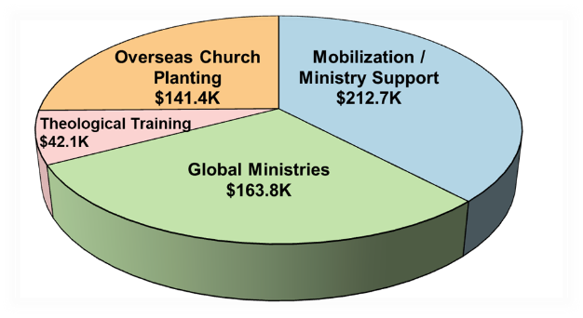



1. **2023 FECA Sending Budget (SF) for Field Workers: $340,000**

Sending Fund is to provide financial support for FECA-sent field workers who are members of FECA churches and to maintain FECA as their sending agency. For detailed information, please visit www.feca.org or contact Edwin Leung, FECA Missions Director @323-727-7077 ext. 17.

1. **Intermediate Drum Workshop at FEC Glendale**

Intermediate drum workshop for those on worship teams and/or experience with basic drum playing techniques, taught by Angel Urias, Youth Pastor of FEC Glendale on 11/12. Please contact [mari@fecg.org](mailto:mari@fecg.org) for more information. Register at tinyurl.com/fecadrum or use the QR code. It is limited to only 15 participants.

|  |  |  |  |  |  |  |  |  |  |  |  |  |  |
| --- | --- | --- | --- | --- | --- | --- | --- | --- | --- | --- | --- | --- | --- |
| **Last Sunday's Worship In-Person Attendance and Offering** | | | | | | | | | | | | | |
|  | ***Glendale*** | ***SGV*** | | ***FECC*** | | | | | ***Diamond Bar*** | | ***ACC*** | ***Arcadia*** | |
| *SGV* | *HOA* | *Cerritos* | *Fullerton* | *Oakland* | | *E. Lansing* | *Arcadia* | *GCDC* |
| ***Mandarin*** | 95 | 103 | 38 | 61 (am), 68 | 38 | 68 | | 8 | 73 | | -- | 30 | 14 |
| ***Cantonese*** | 21 | 71 | -- | 55 | -- | -- | | -- | 82 | | -- | 82 | -- |
| ***English*** | 119 | 73 | -- | 47 | 49 | -- | | -- | -- | | 92 | 51 | -- |
| ***Youth*** | w/Eng. | 40 | 5 | w/Kairos | w/Eng. | 33 | | -- | 21 | | -- | 24 | -- |
|  | |  | | Kairos: 76 | **Total: 1,537** | | | | | | | | |
|  | | ***Glendale*** | | ***SGV*** | ***FECC*** | | ***Diamond Bar*** | | | ***ACC*** | | ***Arcadia*** | |
| ***General Fund*** | | 22,139.36 | | 21,531.75 | 11,857.16 | | 12,286.20 | | | 3,143.16 | | 6,026.00 | |
| ***FECA Mission Fund*** | | 1,390.00 | | 840.00 | -- | | 2,050.00 | | | -- | | 2,722.43 | |
| ***Others*** | | 615.00 | | 1,010.00 | 434.00 | | -- | | | 90.08 | | 19,023.54 | |
| ***09/22 Sur./Def.*** | | 23,374 | | (81,791) | (17,312) | | (13,840) | | | 5,875 | | (11,355) | |
| ***01-09/22 Sur./Def.*** | | 236,073 | | (341,972) | 22,071 | | (91,169) | | | 10,326 | | (23,819) | |