**October 16, 2022**

**Welcome!** *We are so glad you joined us today.*

*We pray that you will be blessed!*

Speaker: Dr. Allen Yeh

Message: Unreached People Groups

Text: Matthew 28

*18 Jesus came and told his disciples, “I have been given all authority in heaven and on earth. 19 Therefore, go and make disciples of all the nations, baptizing them in the name of the Father and the Son and the Holy Spirit. 20 Teach these new disciples to obey all the commands I have given you. And be sure of this: I am with you always, even to the end of the age.”*

Announcements:

1. This weekend is our Association Missions Conference. We welcome Dr. Allen Yeh, Professor, Cook School of Intercultural Studies, Biola University as our speaker;

* Our Missions pledge cards are for everyone to help in our association world-wide missions endeavors. Please give.

1. Harvest Festival will be on Saturday, October 29. We are in need of volunteers. Please contact our Children’s Director Joyce.
2. Sunday school is going on. Please join us each Sunday 10:30-11:30 am at the second floor. “What We Believe” will cover each section from our Statement of Faith in our Bylaws;
3. Our prayer meeting is on Zoom! Please join Wednesdays (8-9:30 pm) to pray for the world, our missionaries, our country and our needs.

Zoom Meeting ID: 865 2394 9892 Passcode: PRAY

1. We have 7 small groups you can join. Please contact Pastor Mongens;
2. Please pray for complete healing:

* Jennifer Lou’s complete healing from kidney transplant;
* Lynn See’s recovery and daughter-in-law Amy (kidney)



**First Evangelical Church Association**

*A joint & integrative ministry of spirituality, missions, social concern and Church Planting*

***FECA Theme for 2022: “Expanding our Horizons:   
 Reaching the Unengaged People Groups”***

October 16, 2022

**2022 Joint Missions Conference – Expanding Our Horizons: Reaching Unreached People Groups**

Many thanks to the two main speakers, workshop speakers, missions display participants, senior pastors, congregational pastors, co-workers, and LMC members for making this year’s missions conference possible. We continue to pray that the inspiring stories, messages, and discussions will bring forth actions and participation in our missions efforts.

**2023 FECA General Missions Fund (GMF) Budget: $560,000**

Your financial contributions are making a difference in global missions. Your giving supports the following focus areas: *Overseas Church Planting /Evangelism, Theological Training, Mobilization / Ministry support, and Ministries**(China, Taiwan, Hong Kong, Cambodia, Thailand, Myanmar, India, Nepal, Pakistan, Middle East, N. Iraq, North Africa, Belize, Mexico, USA).* Visit www.feca.org for online giving. Participate in the 2023 GMF faith pledge (we will collect pledge cards throughout the month of October), or fill out an online e-pledge.

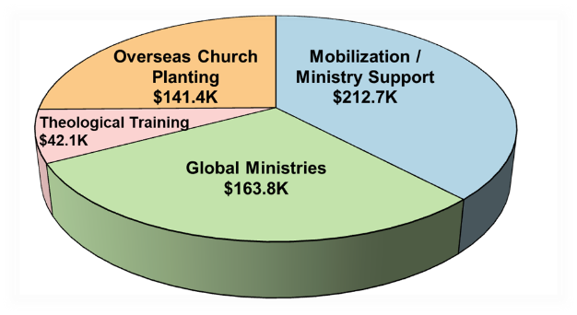



**2023 FECA Sending Budget (SF) for Field Workers: $340,000**

Sending Fund is to provide financial support for FECA-sent field workers who are members of FECA churches and to maintain FECA as their sending agency. For detailed information, please visit www.feca.org or contact Edwin Leung, FECA Missions Director @323-727-7077 ext. 17.

|  |  |  |  |  |  |  |  |  |  |  |  |  |  |
| --- | --- | --- | --- | --- | --- | --- | --- | --- | --- | --- | --- | --- | --- |
| **Last Sunday's Worship In-Person Attendance and Offering** | | | | | | | | | | | | | |
|  | ***Glendale*** | ***SGV*** | | ***FECC*** | | | | | ***Diamond Bar*** | | ***ACC*** | ***Arcadia*** | |
| *SGV* | *HOA* | *Cerritos* | *Fullerton* | *Oakland* | | *E. Lansing* | *Arcadia* | *GCDC* |
| ***Mandarin*** | 82 | 171 | 40 | 64 (am), 52 | 43 | 67 | | 23 | 82 | | -- | 27 | 23 |
| ***Cantonese*** | 18 | 79 | -- | 64 | -- | -- | | -- | 76 | | -- | 92 | -- |
| ***English*** | 118 | 57 | -- | 50 | 69 | -- | | -- | -- | | 112 | 45 | -- |
| ***Youth*** | w/Eng. | 38 | 5 | w/Kairos | w/Eng. | 25 | | -- | 18 | | -- | 20 | -- |
|  | |  | | Kairos: 78 | **Total: 1,638** | | | | | | | | |
|  | | ***Glendale*** | | ***SGV*** | ***FECC*** | | ***Diamond Bar*** | | | ***ACC*** | | ***Arcadia*** | |
| ***General Fund*** | | 19,030.36 | | 22,137.41 | 16,531.56 | | 10,884.25 | | | 8,026.46 | | 11,567.00 | |
| ***FECA Mission Fund*** | | 850.00 | | 1,180.00 | -- | | -- | | | -- | | 450.00 | |
| ***Others*** | | 795.00 | | 945.00 | 1,275.00 | | 100.00 | | | 131.05 | | 1,865.46 | |
| ***09/22 Sur./Def.*** | | 23,374 | | (81,791) | (17,312) | | (13,840) | | | 5,875 | | (11,355) | |
| ***01-09/22 Sur./Def.*** | | 236,073 | | (341,972) | 22,071 | | (91,169) | | | 10,326 | | (23,819) | |