Jesus, Who Are You?
I Am the Door
Lesson 7

Discussion:
1. Share your thoughts on Pastor Mongens’ message.

2. Today’s passage: John 10:1“Truly, truly, I say to you, he who does not enter by the door into the fold of the sheep, but climbs up some other way, he is a thief and a robber.
2 But he who enters by the door is a shepherd of the sheep….. 7 So Jesus said to them again, “Truly, truly, I say to you, I am the door of the sheep. 8 All who came before Me are thieves and robbers, but the sheep did not hear them. 9 I am the door; if anyone enters through Me, he will be saved, and will go in and out and find pasture. 10 The thief comes only to steal and kill and destroy; I came that they may have life, and have it abundantly.

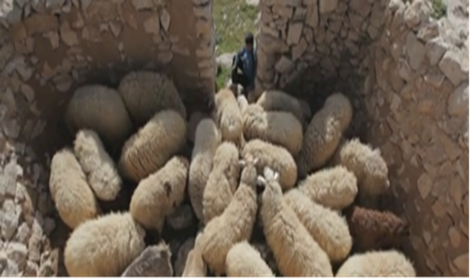

- Looking at the picture of a sheepfold above, how would a thief or robber attempt to steal the sheep?
- What does the picture say about the responsibility of the shepherd?
- How would you feel as a sheep in this sheepfold?
- Yet as sheep, how come we tend to wander off easily?

3. John 10:10 “The thief comes only to steal and kill and destroy;”
- What are the ways Satan comes to “steal, kill and destroy?”
-your body -your emotions -your spiritual life
-your mind -your family
- Share one struggle where you have seen Satan at work in your life.
- How did you overcome this?

4. John 10:10 “I came that they may have life, and have it abundantly.” The life Jesus offers here is not physical life (bios) or psychological wellbeing (psuche); but ZOE –the divine life uniquely possessed by God.
- What are we allowing into our life that hinders the “abundant life?”
- If Jesus is the door, how can He help us experience the “abundant life?”
- How can we help each other on the way to ZOE?

5. Pray for each other

